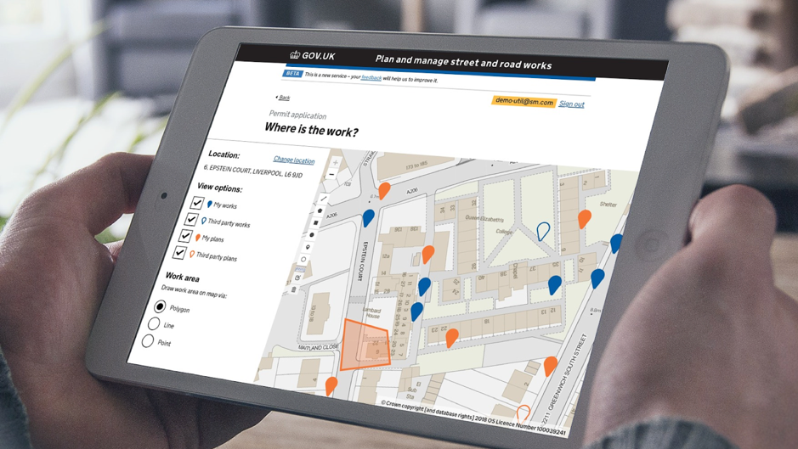

**Newsletter No 13: September 2019**

**STREET MANAGER**

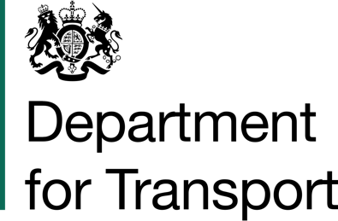

A new approach to road works

Street Manager is a new digital service by the DfT that’s setting out to transform the planning, management and communication of street and road works. Using open data and intelligent services its aim is to minimise disruption – and improve journeys for the public.

Welcome to the latest edition of the Street Manager (SM) newsletter. First up, the countdown to Street Manager Public Beta is on. Launching on 1 November, we strongly recommend your organisation signs up to give yourselves ample time to manage the transition. If you’d like to join, simply email XXXXX. We’ve also included a handy diagram outlining the onboarding process.

Meanwhile, this autumn sees us hosting interactive Street Manager roadshows across the country. These are a great opportunity for you to understand in detail what the transition will mean for your organisation – and how to navigate it. Read on to find out when Street Manager is coming to a town near you.

**Other announcements**

Wondering what’s in store for Street Manager? The scope document outlines the roadmap for the service. Explore this living document which will be updated as the project evolves.

We’ve also been working on the transition rules. These are being developed with the help of our industry Subject Matter Experts, and outline the principles that govern the transition from EToN to Street Manager – and will be ready to view in the coming weeks.

**Joining Street Manager?**

Here’s a quick summary of the process.

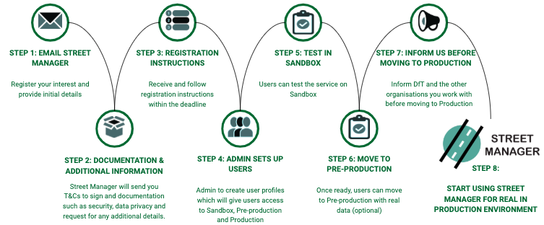

**Find your local Street Manager roadshow**

Here are the dates the Street Managet team is coming to your region. We look forward to welcoming you and answering your questions in these interactive sessions.

* 24 Sep – Doncaster, Yorkshire region
* 30 Sep – Stevenage, Anglia region
* 10 Oct – Taunton, Southwest region
* 16 Oct – Leicester, East Midlands region
* 18 Oct – London
* 29 Oct – Brighton, Southeast region
* 7 Nov - Manchester (TBC), North West region
* West Midlands – date and location TBC
* North East – date and location TBC
* London – date for second event TBC

**Street Manager scope document**

We're pleased to be publishing a new scope document. As this is a live document, this will always contain the most up to date information about the project covering what’s in scope for Private Beta, Public Beta, and post April 2020 – as well as what’s out of scope. Items listed under ‘future’ will be fleshed out once we have more detail on specific features in these areas.

If you have a question around scope, the best place to ask is on the DfT Slack channel. This keeps questions public so everyone can see the answer and potentially spark further conversation. If you cannot access Slack, then you can email Street Manager – and we will get back to you as soon as possible.

View the document here:

[https://indd.adobe.com/view/9ffd6398-0623-4dda-9b5e-98d5d186f2a5](https://indd.adobe.com/view/9ffd6398-0623-4dda-9b5e-98d5d186f2a5" \t "_blank)

**The Hole Story**

View episode 13 of Hole Story, the latest instalment of our feature overview videos, which covers admin functionality as well as setup and operation of workstreams:

<https://www.youtube.com/watch?v=-RIFy7-xeAA&feature=youtu.be>

You can also watch previous episodes of The Hole Story and other Street Manager videos on our YouTube channel:

<https://www.youtube.com/channel/UC2U1cjhn4KGPDCwzqc-tvbg/videos?view=0&sort=dd&shelf_id=0>

**API update**

We have now added functionality to allow users to create, view and manage events and licences. The UI functionality for this will be coming in the next few weeks, while the API endpoints are already available within the Sandbox environment. What’s more, foundation work has begun for Forward Plans.

Throughout the month of September, the team will be working to update the API specification in preparation for the start of the Public Beta phase. This will be published and available for users on 30 September. Developers will be able to use this version to start or continue their work on their integrations.

As project continues to implement the roadmap, and throughout the Public Beta phase, minor updates will continue to rolled out as we add new functionality or endpoints. For those that wish to take advantage of updates, you will be able to do so as soon as they’re released.

**Business Change updates**

Public Beta is fast approaching so now is the time to think about the business change aspect of your transition. With that in mind, the focus this month is on two key things: impact assessment and project plan.

**1) Impact assessment**– how will the change impact your organisation's teams, individuals, processes, ways of working? Doing an impact assessment will help you gain an understanding of these questions, make informed decisions and plan your actions accordingly.

**Tips**: Have a look at the Impact assessment tool and guidance on GitHub:

[https://departmentfortransport.github.io/street-manager-docs/assets/files/business-change/Impact%20assessment.xlsx](https://departmentfortransport.github.io/street-manager-docs/assets/files/business-change/Impact%20assessment.xlsx" \t "_blank)

Also, expore our 'How to' video tutorial: [https://www.youtube.com/watch?v=6S1X6uiH99g](https://www.youtube.com/watch?v=6S1X6uiH99g" \t "_blank)

**2) Project and change management plan** – whether you prefer a summary 'roadmap' style or a detailed activity schedule, now is the time to think about what needs to take place to get your organisation on Street Manager and embed this into your BAU.

**Tips:**Have a look at the templates, guidance and best practice available on GitHub:

[High level roadmap](https://departmentfortransport.github.io/street-manager-docs/assets/files/business-change/Street%20Manager%20-%20High-level%20roadmap.pptx" \t "_blank)

[Delivery project plan](https://departmentfortransport.github.io/street-manager-docs/assets/files/business-change/Delivery%20and%20roll-out%20plan.xlsx" \t "_blank)

[Change management approach](https://departmentfortransport.github.io/street-manager-docs/assets/files/business-change/Playbook%20Street%20Manager%20Change%20management%20strategy.pptx" \t "_blank)

For any questions on these, do not hesitate to contact us via email or on Slack using the #askdft or #businesschange channels.

We look forward to seeing you at the autumn roadshows!

**Transition rules update**

We have been working on the transition rules that govern the move from EToN to Street Manager. The general principles are as follows:

|  |
| --- |
|  |
| 1. Any works raised in EToN prior your organisation’s transition to Street Manager must be completed and registered in EToN by no later than 30 April 2020. |
| 2. All new works raised after your transition date must be raised in Street Manager |
| 3. Any works raised in EToN planned to start on or after the 1 May 2020, or any ‘in progress’ works across this period will need to be re-raised in Street Manager before 1 May 2020. |

The document will be divided into 3 tabs:

* One holds the basic rules on and recommendations to work together at an early stage
* Another explains where a permit is to be served (EToN or Street Manager) based on the planned end date of the works
* The final one provides real life scenarios for after 30 April 2020

This will be ready and available in the coming weeks – so keep an eye out.

**Keeping in touch**

We are pleased that so many of you have signed up to our Slack channel. We now have 648 members. For those that haven’t yet, please consider signing up as this is how we’re answering questions, giving updates and asking for your help through detailed questions. The Slack channel is also a valuable way for users to share knowledge among themselves.

Slack is available as an app, and it's free. Just to note, when signing up, please use your organisation in your display name as that helps identify you. We welcome questions, and encourage discussion.

Within the Slack channel there is also a document store that gives you access to previous newsletters and slide decks.

To sign up visit: <https://join.slack.com/t/dftstreetmanager/shared_invite/enQtNDE1MzYyODg1OTIzLTI2NTQzMDBiYjIxZDhiNjljODY1YzllM2ExNTBlZDBlYjY4MzY3NDViNWFhYzY3YjU2YzcyY2VkNDM3YmNmMjE>

Contact us

Thank you to those who have been in touch this month. A reminder that if you wish to sign up to Street Manager or have any queries, please email:

[streetmanager@dft.gov.uk](mailto:streetmanager@dft.gov.uk)

or contact us on the #askthedft Slack channel.

